**Agroecology living lab**

**Master/ Bachelor Thesis Project (Master-/ Bachelorarbeit)**

We are looking for motivated Bachelor/Master student who is interested in agroecology, regenerative farming or sustainable food systems.

**Background**

Transitioning from the globalised, unsustainable and vulnerable to Agroecology-based Local Agri-food Systems (ALAS) is an urgent challenge that the EU is currently facing. However, there is little scientific evidence on how these systems would be, their social and ecological impacts and how to scale them. At the same time, it is also clear that this agroecological transition must be done together with the different actors that are involved in the ALAS. How to do this? A novel approach is the living lab, which allows addressing complex challenges involving multiple actors and disciplines.

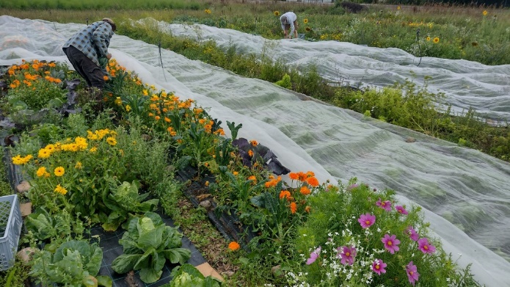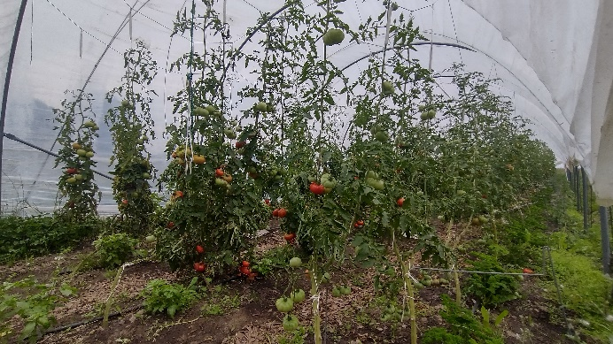

**Master Thesis Project**

The project will take place in a farm in the island of Bornholm, a Community-Supported Agriculture (CSA) farm with the purpose of becoming an agroecology living lab and a lighthouse for the farmers in the island.

You can choose the topic (see below the list of potential topics), which must be agreed with the farmers. The project will be co-designed with the farmers, following the living lab approach. The fieldwork should take place during the growing season of 2024 (April-September). The methodology will depend on the selected topic.

**Contact information**

**List of potential topics**

Food systems

* Social impacts from alternative food networks
* Solidarity-based business models and social innovations in agri-food systems
* Re-connecting consumers and producers in agri-food systems
* Fostering food culture and sustainable and healthy diets through agroecology-based regional farming

Agroecosystems

* From organic to agroecological, re-designing farms to creating landscapes
* Impact from regenerative soil practices on key soil characteristics (e.g. organic matter, nutrients, structure, microbial diversity and activity)
* Impact from species diversification on pest control and crop resilience
* Impact from species diversification on wild biodiversity
* Production and yields in highly diversified farms
* Agro-ethnography, ethnobotany, use of traditional species and testing new ones

Holistic analyses

* Social-ecological impacts of the farm (application of systemic principles-based tools, e.g. TAPE tool)

Transdisciplinary science

* Co-design of an agroecology living lab
* Development a strategy for citizen science in the farm
* Exploring the out-scaling (replication) of the system in the island